Quit Together – Social Media Supporters Pack

Ethos: positive, supportive, empowering

Graphic for post (NOTE – remember to use graphics from the relevant folder when posting on Twitter, Facebook or Instagram) | Twitter and Instagram post content  (feel free to personalise) | Facebook post content  (feel free to personalise)
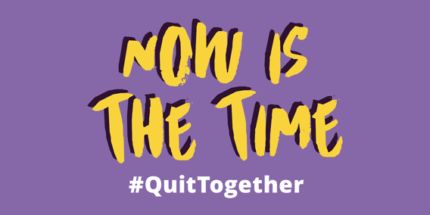 | Join hundreds of others who will stop smoking today.  www.quittogether.co.uk  #QuitTogether | Join hundreds of others who will stop smoking today.  www.quittogether.co.uk
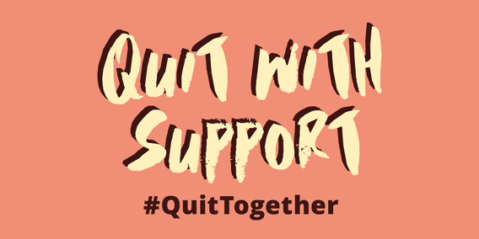 | You are 3 times more likely to quit with medicine and support from your local Stop Smoking Service. Friendly help and support is still available.  www.quittogether.co.uk/help-available | You are 3 times more likely to quit with medicine and support from your local Stop Smoking Service. Friendly help and support is still available.  www.quittogether.co.uk/help-available
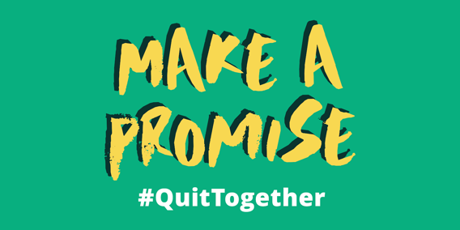 | Support a loved one to quit or quit for someone you love.  www.quittogether.co.uk/quit-together  #QuitTogether | Support a loved one to quit or quit for someone you love.  www.quittogether.co.uk/quit-together
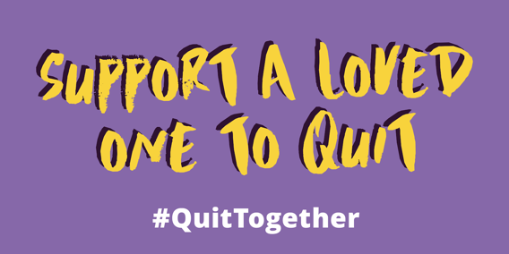 | Telling a friend, a family member, a neighbour that you will help them quit smoking could be the thing that helps them to start.  www.quittogether.co.uk/quit-together  #QuitTogether | Telling a friend, a family member, a neighbour that you will help them quit smoking could be the thing that helps them to start.  www.quittogether.co.uk/quit-together
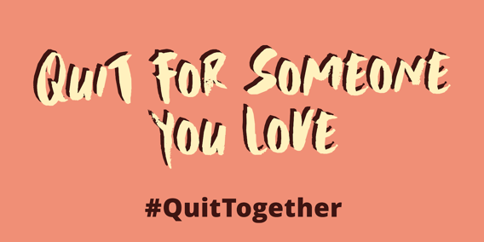 | Children smoke because adults smoke. You stop, they won’t start.  www.quittogether.co.uk  #QuitTogether | Children smoke because adults smoke. You stop, they won’t start.  www.quittogether.co.uk
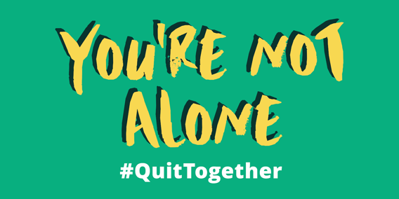 | *Tweet as a thread*  1)Join hundreds of others who will stop smoking today.  www.quittogether.co.uk  #QuitTogether  2) North Lincs Contact: nlc.healthylifestyles@nhs.net  or 01724 298212  3) NE Lincs Contact:  wellbeingservice@nelincs.gov.uk or 01472 325500  4) East Riding Text QUIT to 60163.  Contact: HNF-TR.healthtrainers@nhs.net or 0800 9177752 | Join hundreds of others who will stop smoking today.  www.quittogether.co.uk  North Lincs Contact: nlc.healthylifestyles@nhs.net  or 01724 298212  3) NE Lincs Contact:  wellbeingservice@nelincs.gov.uk or 01472 325500. Message @LiveWellNEL  East Riding Text QUIT to 60163.  Contact: HNF-TR.healthtrainers@nhs.net or 0800 9177752
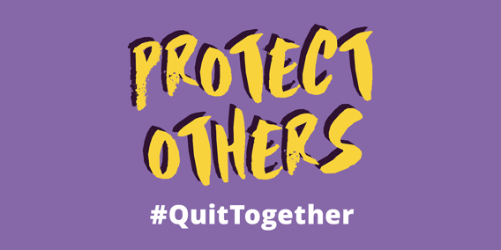 | A smokefree home protects your family.  Harmful chemicals in tobacco smoke creep from room to room, waiting for your child to breathe them in. However, evidence suggests e-cigarettes are 95% less harmful with no evidence of harm to bystanders.  www.quittogether.co.uk/protect-others  #QuitTogether | A smokefree home protects your family.  Harmful chemicals in tobacco smoke creep from room to room, waiting for your child to breathe them in. However, evidence suggests e-cigarettes are 95% less harmful with no evidence of harm to bystanders.  www.quittogether.co.uk/protect-others
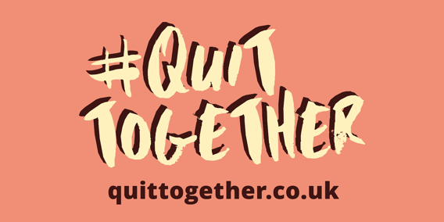 | Quitting smoking with the support of friends, family and your neighbours can be the encouragement one person needs to stop.  www.quittogether.co.uk  #QuitTogether | Quitting smoking with the support of friends, family and your neighbours can be the encouragement one person needs to stop.  www.quittogether.co.uk
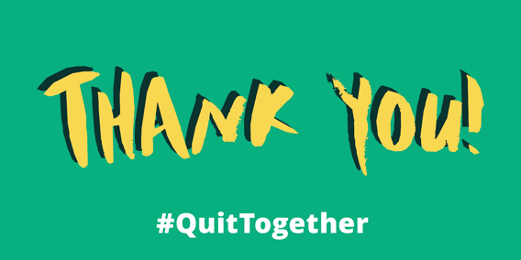 | High Five to everyone who’s currently quitting smokers or those who helping other to  www.quittogether.co.uk/quit-together  #QuitTogether | High Five to everyone who’s currently quitting smokers or those who helping other to  www.quittogether.co.uk/quit-together
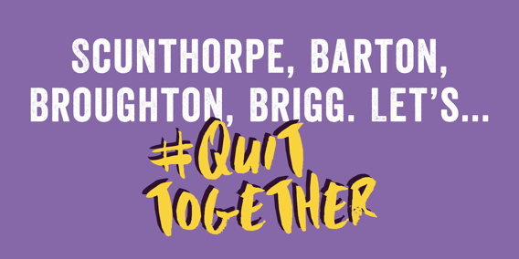 | You are 3 times more likely to quit with medicine and support from your local Stop Smoking Service. Friendly help and support is still available.  www.quittogether.co.uk/help-available  Contact: nlc.healthylifestyles@nhs.net  or 01724 298212 | You are 3 times more likely to quit with medicine and support from your local Stop Smoking Service. Friendly help and support is still available.  www.quittogether.co.uk/help-available  Contact: nlc.healthylifestyles@nhs.net  or 01724 298212
 | You are 3 times more likely to quit with medicine and support from your local Stop Smoking Service. Friendly help and support is still available.  www.quittogether.co.uk/help-available  Contact:  wellbeingservice@nelincs.gov.uk or 01472 325500 | You are 3 times more likely to quit with medicine and support from your local Stop Smoking Service. Friendly help and support is still available.  www.quittogether.co.uk/help-available  Contact:  wellbeingservice@nelincs.gov.uk or 01472 325500. Message @LiveWellNEL
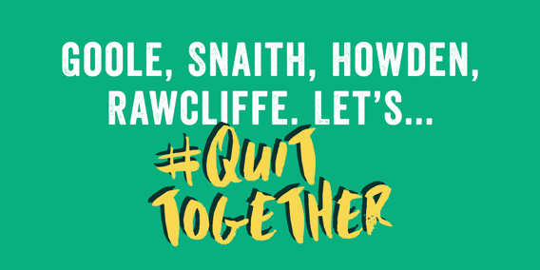 | You are 3 times more likely to quit with medicine and support from your local Stop Smoking Service. Friendly help and support is still available.  www.quittogether.co.uk/help-available  Text QUIT to 60163  Contact: HNF-TR.healthtrainers@nhs.net or 0800 9177752 | You are 3 times more likely to quit with medicine and support from your local Stop Smoking Service. Friendly help and support is still available.  www.quittogether.co.uk/help-available  Text QUIT to 60163  Contact: HNF-TR.healthtrainers@nhs.net or 0800 9177752
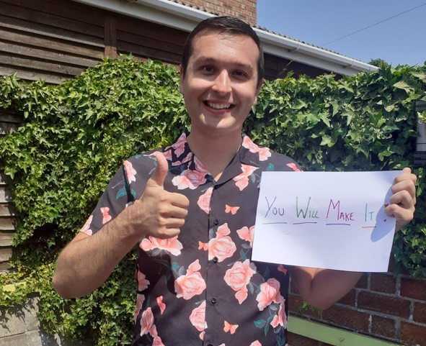 |  | [example]  Ashley from Scunthorpe, an Occupational Therapy Assistant for RDaSH is supporting smokers trying to quit.  To support those quitting @Northern Lincolnshire and Goole NHS Foundation Trust is asking you to share ‘feel good’ photos and videos to show you are behind those wanting to quit. Tag them into your post to appear on the website www.quittogether.co.uk/quit-together

